Criterion D – Rubric
Level | Description | Questions
0 | You are not able to attempt solving any problem. | --
1 – 2 | You are able to predict the structure of a fence with 4 sections and 5 sections. You are able to calculate how much it would cost to build these two structures. You identify a pattern and write a rule for it according to your findings. | (a) to (e)
3 - 4 | You are able to model the real-life problem by using a pattern rule. You are able to verify your rule. You are able to attempt to answer the real-life problem by writing and verifying a general formula for the number of wooden lengths. | (a) to (h)
5 – 6 | You are able to model the real-life problem by using a pattern rule. You are able to verify your rule. You are able to partially answer the real-life problem by correctly writing and verifying a general formula for the number of wooden lengths, and by writing and verifying a formula to calculate the total cost of any fence. | - to (i)
7 – 8 | You are able to model the real-life problem by using a pattern rule. You are able to verify your rule. You are able to fully answer the real-life problem by correctly writing and verifying general formulas for the number of wooden lengths and for the cost of any fence. You correctly calculate the cost of a 50-section fence. You are able to explain whether or not a new formula would make sense when the cost of wood increases. | - to (l)

This problem is about a company that builds fences. They build wooden fences with the structure types shown below. So, a 1-section fence takes five wooden lengths, a 2-section fence takes 9 wooden lengths, and so on.
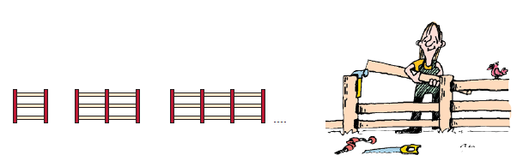

THE PROBLEM
You have been hired by this company to create a practical way to calculate the cost of building a fence of any type. You just know the type of structures they build and the price of wood: 1 length of wood costs QR 6.

Part 1: Understanding the problem.

- Draw the sketch of the following fence structures: 1-section, 2-section, 3-section, 4-section and 5-section.

 | 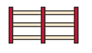 | 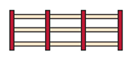
1-section | 2-section | 3-section | 4-section | 5-section

- Write down the number of wooden lengths required to make: 4 sections and 5 sections.

- Calculate the cost of building a 2-section fence.

Part 2: Using a pattern to model the problem.

- Model the problem using a pattern. (Use the back of the paper for your work.)

- Write down the rule that explains the pattern.

- Verify your rule. If the rule does work, go to the next question. If the rule does not work, write another rule and verify it.

- Write the formula that allows you to calculate how many wooden length are needed to build a fence with n sections.
- Verify your formula.

Part 3: Answering the problem.

- Use your formula and the price of wood to calculate the cost of building a fence of 1 section.

- Write the formula that allows you to calculate the cost of building a fence with n sections.

Cost of a n-section fence =

- Calculate the cost of building a fence of 50 sections.

- If the price of wood goes up, and your formula becomes
Cost of one n-section fence = 32n + 8
Does the new formula make sense? Explain your answer

